** Joseph Banks Secondary College**

Year 12 General Integrated Science

Task 3: Lake Joondalup Environmental

Impact Statement

**Assessment type:**

Science Inquiry

______________________________________________________________________________________

**Assessment Weighting:**

10% of the year.

______________________________________________________________________________________

**Conditions:**

Periods allowed for completion of the task:

* 3 lessons of class time to complete data analysis and write up.
* One week of additional home time to complete the assessment.

___________________________________________________________________________________

**Directions:**

* Use the historical data, to prepare an environmental impact statement for the construction of a new bridge at Lake Joondalup.
* Your report must contain **THREE** graphs, two from table 1 and one from table 2. All graphs must be hand drawn using a ruler and pencil.
* Report may be typed; however graphs must be hand drawn.
* Use the provided marking guide to plan the structure of your Environmental Impact Statement.
* The marking guide for this assessment is located at the end of this booklet, refer to this for the distribution of marks.

____________________________________________________________________________________________________

**Background:**

Ecosystems within Australia need to be monitored to ensure their ongoing health and the health of the species within them. To achieve this, Environmental Scientists and Ecologists will look at different environmental indicators within the system to gauge its health. Typically, scientists will record a number of abiotic and biotic factors in the system to gain information on species diversity and abundance.

Lake Joondalup lies within the Yellagonga Catchment Area, the catchment lies on the Swan Coastal Plain and is located approximately 20 km north of central Perth. The surface water catchment area impacting on the Park is estimated to cover an area of approximately 400 hectares. The catchment is linked to the park by surface flows via drainage infrastructure and groundwater flows. The catchment encompasses land on either side of the park located in the Cities of Joondalup and Wanneroo and includes medium to high-density residential, commercial and light industrial development interspersed with green areas. Lakes Joondalup and Goollelal, and the swamps Beenyup and Walluburnup, are the receiving aquatic environments for water from this catchment via surface and groundwater flows. The water of lake is slightly alkali due to underlying limestone bedrock. This keeps the pH of the lake water in the region of 8.2 – 8.5.

Within these systems, freshwater invertebrates (insects, crustaceans, snails and worms) are often used as indicators of the state of streams, rivers, lakes and ponds. As seasons change, the diversity and abundance of invertebrates can change as water temperature and quality changes. In this report, you will be comparing the species diversity and abundance of freshwater invertebrates over time within Lake Joondalup.

In an attempt to improve access to Joondalup, the government has announced a plan to construct a bridge across the middle of Lake Joondalup, connecting Wanneroo and Joondalup. The bridge will be four lanes wide and is expected to be crossed 52,000 times per day by cars, trucks and buses. The bridge will sit on six large pillars buried in the mud of the lake. Water runoff from the road surface will be transported to the lake via stormwater drains. It is expected that 900m3 of lake mud, soil and rock will need to be removed for the pillars to be placed. The soil and mud of the lake is classified as an acid-sulphate soil. When immersed in water, the soil is stable however when exposed to Oxygen, the sulphates in the soil react to form Sulphuric Acid. In order for the concrete pillars to be built, the holes must be drained of water and left to dry for a month before they are filled with concrete. The acid-sulphate soil taken from the lake will be dumped at a local landfill site. In order to help the bridge blend into local surrounds, large gardens will be built on the sides of the ramp leading to each bridge. This will be sprayed 4 times per year with fertiliser.

It is expected that construction of the bridge will take 20 months and will produce significant noise pollution and vibration in the lake during construction as well as throughout the life of the bridge due to vehicle traffic. During construction, the bridge will be lit at night-time with 200 large floodlights to keep the area illuminated. It is expected that the light produced will extend out 100m either side of the bridge at night. The number of lights will be reduced down to 100 lights after the bridge has been completed.

Yellagonga Regional Park has cultural and historical significance to both Aboriginal and non- Aboriginal people. There are seven listed Aboriginal sites within the Park known to the Department of Indigenous Affairs (DIA) and another four sites adjoining the Park. In addition, there are other possible sites, which are yet to be listed by the DIA. Land comprising Yellagonga Regional Park is significant to the local Aboriginal people (Nyungars) because it was an important camping area used widely for watering, food-gathering, camping and tool-making, hunting and corroborees, and summer social life (Brittain, 1990).

In the Aboriginal seasonal cycle of camp movements, it was used as an east-west staging between the foothills and the ocean, and a north- south staging between Mt. Eliza and the Moore River. The lands of Yellagonga Regional Park comprised a significant camp due to its centrality within the Mooro district, its proximity to the ocean and other lakes and the abundance of food including wildfowl, kangaroos and other marsupials (Brittain 1990).

The government have approached you to construct an environmental impact statement (EIS) on potential changes to the lakes water chemistry and invertebrate species abundance and diversity. They have provided the following historical data on the lake. In 2009, Ocean Reef Road was constructed across the Southern end of the lake. This resulted in increased water runoff from the road into the lake.

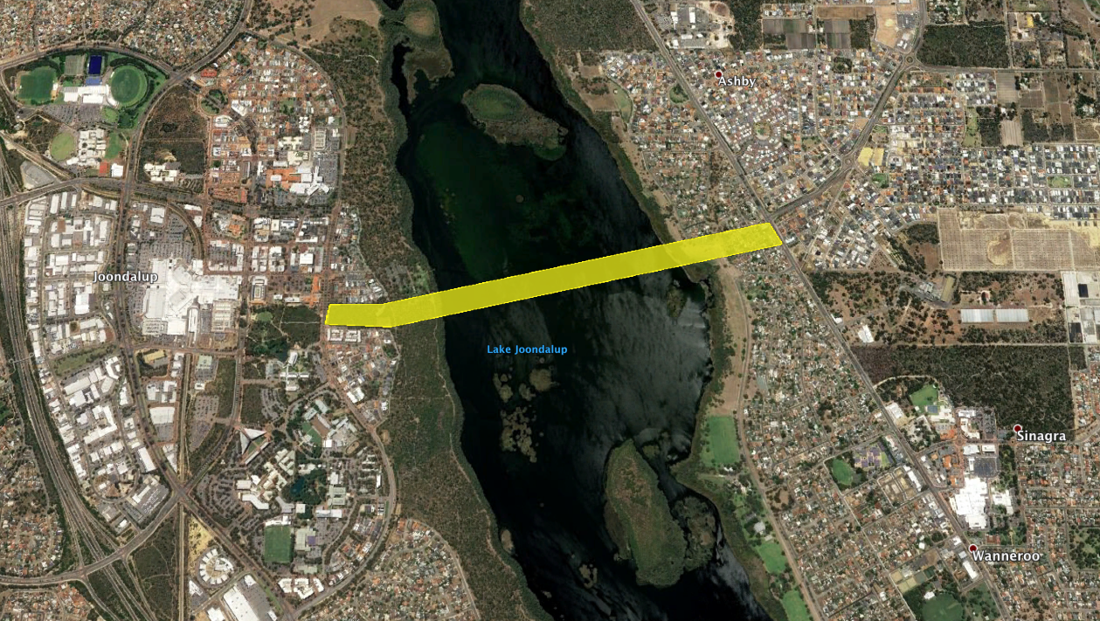

Figure 1: Proposed route of new traffic bridge linking Joondalup and Wanneroo.

Lake Joondalup is home to many different species, including several threatened species. In particular, the lake falls within the Northern Swan Coastal Plain Important Bird Area. The lake is home to the non-breeding range of Carnaby’s Black Cockatoo, an endangered species of cockatoo. The lake is also home to several species of threatened migratory shorebirds In recognition of the need for international action to maintain migratory bird populations, Australia has signed bilateral agreements with China, Japan and the Republic of Korea to protect shorebirds and their habitats, and all are signatories to the Convention for the Protection of Wetlands of International Importance (Ramsar Convention). A flyway represents the collective migration routes of waterbirds, including shorebirds, between their breeding and non-breeding areas. There are nine flyways globally: the East Asian - Australasian Flyway (EAAF) encompasses Australia, New Zealand and another 21 countries. Threatened migratory birds known to have used Lake Joondalup as a foraging site include: Great Knot, Curlew Sandpiper, Lesser Sand Plover, Grey-tailed Tattler, Eastern Curlew and Australasian Bittern. These birds rely upon areas of open mudflat upon which to forage.

**References**:

Brittain R.K., (1990), Yellagonga Regional Park – Ethnology Position Paper, Kidd and Povey Pty Ltd, Yokine, prepared for the Department of Planning and Urban Development, Perth, Western Australia.

Department of Conservation and Land Management, (2003). Yellagonga Park Regional Management Plan, Perth, Western Australia.

["Important Bird Areas factsheet: Northern Swan Coastal Plain"](http://www.birdlife.org/datazone/sitefactsheet.php?id=26933). [BirdLife International](https://en.wikipedia.org/wiki/BirdLife_International). Retrieved 14 May 2019.

**Table 1:** Water chemistry data from Lake Joondalup over multiple sampling years.

|  |  |  |  |  |  |  |  |  |
| --- | --- | --- | --- | --- | --- | --- | --- | --- |
| **Year** | **Temperature (°C)** | **pH** | **Salinity (ms/cm)** | **Turbidity (NTUs)** | **Dissolved Oxygen (%)** | **Phosphates**  **(Ppm/mgL)** | **Petroleum (mg/L)** | **Nitrates (Ppm/mgL)** |
| **1999** | 21.1 | 8.5 | 2.8 | 5 | 102 | .05 | 1.2 | .05 |
| **2001** | 21.4 | 8.6 | 2.7 | 6 | 100 | .04 | 1.1 | .04 |
| **2004** | 24 | 8.4 | 2.9 | 5 | 103 | .05 | 1.3 | .04 |
| **2007** | 22.1 | 8.7 | 2.8 | 6 | 102 | .05 | 1.2 | .05 |
| **2010** | 22.6 | 6.5 | 3.1 | 12 | 89 | .07 | 2.9 | .07 |
| **2013** | 23.2 | 7.1 | 3.3 | 12 | 91 | .06 | 3.0 | .06 |
| **2016** | 23.9 | 7.4 | 3.4 | 13 | 92 | .07 | 2.9 | .08 |
| **2019** | 24.2 | 7.9 | 3.3 | 13 | 95 | .07 | 3.1 | .06 |

|  |  |  |  |  |  |  |  |  |  |  |
| --- | --- | --- | --- | --- | --- | --- | --- | --- | --- | --- |
| **Macroinvertebrate** | **Classification** | **Disturbance Tolerance Level** | **Species Abundance and Diversity Per Year** | | | | | | | |
| **1998** | **2001** | **2004** | **2007** | **2010** | **2013** | **2016** | **2019** |
| *Stonefly Nymph | Plecoptera | Very sensitive | 75 | 70 | 56 | 50 | 0 | 0 | 10 | 11 |
| Mayfly Nymph | Ephemeroptera | Very sensitive | 28 | 30 | 23 | 18 | 0 | 0 | 0 | 8 |
| *Damselfly Nymph | Odonata | Tolerant | 57 | 49 | 45 | 56 | 0 | 34 | 45 | 63 |
| Freshwater Shrimp | Decapoda | Very tolerant | 87 | 82 | 90 | 93 | 70 | 78 | 85 | 98 |
| Leech | Hirudinea | Very tolerant | 5 | 6 | 5 | 7 | 6 | 5 | 5 | 6 |
| Freshwater Snail | Gastropoda | Very tolerant | 23 | 29 | 23 | 25 | 12 | 15 | 18 | 20 |
| *Water mite | Acarina | Sensitive | 13 | 15 | 16 | 17 | 0 | 0 | 0 | 2 |
| *Water Boatman | Corixidae | Very tolerant | 49 | 45 | 56 | 60 | 103 | 95 | 86 | 79 |
| *Dragonfly Nymph | Odonata | Tolerant | 31 | 35 | 34 | 42 | 0 | 4 | 18 | 14 |
| *Caddisfly Larvae | Trichoptera | Very sensitive | 18 | 16 | 21 | 19 | 0 | 1 | 2 | 0 |
| Biting Midge Larvae | Ceratopogonidae | Tolerant | 42 | 48 | 52 | 36 | 0 | 0 | 0 | 0 |
| Freshwater Mussel | Bivalvia | Tolerant | 3 | 2 | 5 | 3 | 0 | 2 | 1 | 3 |
| *Springtail | Collembola | Very tolerant | 17 | 23 | 12 | 16 | 34 | 31 | 37 | 45 |
| Flatworm | Turbellaria | Very tolerant | 13 | 16 | 14 | 10 | 12 | 13 | 10 | 16 |
| *Ostracod | Ostracoda | Sensitive | 7 | 3 | 1 | 2 | 0 | 0 | 2 | 6 |
| Crane Fly Larvae | Tipulidae | Tolerant | 6 | 9 | 8 | 6 | 0 | 2 | 6 | 8 |

**Table 2:** Macroinvertebrate species diversity, abundance and pollution tolerance levels during sampling years.

**What You Will Need to Include in Your Environmental Impact Statement (EIS):**

**Hint:** An EIS is document that describes the positive and negative environmental effects of a proposed action. It usually lists some alternative actions that may be chosen instead of the action described in the EIS.

You will be provided with lined paper and graph paper. Make sure to include all required headings: Introduction, Variables, Results, Analysis, Reliability and Validity, Mitigation, Evaluation, Conclusion.

|  |  |
| --- | --- |
| **Section** | **Description** |
| **Introduction**  (6 marks) | * Provides background information about the location of the proposed project. * Provides background information about the proposed project. * Provides a description on the purpose and need. |
| **Variables**  (7 marks) | * Correctly names the independent variable and uses the correct units. * Correctly names at least 2 dependent variables and uses the correct units. * Correctly states three controlled variables and explains how they will be controlled. |
| **Results**  (23 marks) | * Creates 2 graphs from table 1 (using all variables). Hint you need to use two vertical axis per graph. * Creates 1 graph from table 2 (using macroinvertebrates with a star infront of their name) * Must include an appropriate title including variables, axis labels with units, correct scale, data plotted correctly, correct graph type, and a key. * Identifies potential outliers in the raw data and states possible reasons for their value. |
| **Analysis (Discussion)**  (16 marks) | * Describe the patterns and trends visible in the data. * Did the species go up or down over time and why? * Describes the potential impact of abiotic factors on macroinvertebrate species abundance and diversity.   Consider the following questions:  *How will the proposed bridge affect the macroinvertebrate abundance and diversity? Why do you think they will be affected? Refer to your data to support your opinion.  *What are the impacts of changes in macro invertebrate species diversity and abundance?   * Describe potential impacts to other aspects of the Lake Joondalup ecosystem (migratory birds, Indigenous culture, etc). Use background information to assist you. * Provides the positives and negatives outcomes of the bridge being built? |
| **Reliability and Validity**  (4 marks) | * Comments on the reliability of the report. * Comments on the validity of the report. |
| **Mitigation**  (6 marks) | * Provides realistic rules that must be followed by the builder. * Provides recommendations to the bridge plan before it proceeds. * Provides realistic strategies to minimise risk/harm to the Lake Joondalup ecosystem. |
| **Evaluation**  (4 marks) | * Describes at least two limitations with the experiment that may affect the accuracy of the data. * Suggests at least two improvements for the experiment in the future. |
| **Conclusion**  (4 marks) | * Summarises findings from the investigation * Provides a position on the approval or rejection of the bridge. * Provides justification through evidence from the data to justify position. |
| **TOTAL MARKS 70 marks** | |

**Teacher Marking Rubric Student Name:_____________________________**

|  |  |  |  |
| --- | --- | --- | --- |
| **Section** | **Description** | **Marks Allocated** | **Marks Received** |
| **Introduction**  (Description, Purpose and Need) | * Provides background information about the location of the proposed project. * Provides background information about the proposed project. * Provides a description on the purpose and need. | 2  2  2 |  |
| **Variables** | * Correctly names the independent variable and uses the correct units. * Correctly names at least 2 dependent variables and uses the correct units. * Correctly states three controlled variables and explains how they will be controlled. | 2  2  3 |  |
| **Results** | Creates 3 graphs (marks below are based on all 3 graphs)   * Appropriate title including variables. * All axis labels are correct. * All axis labels have units included. * Correct scale. * Key included. * Data plotted correctly-all correct (2 marks), partially correct (1 mark) * Identifies potential outliers in the raw data and states possible reasons for their value. | 3  3  3  3  3  6  2 |  |
| **Analysis** (Discussion) | * Describe the patterns and trends visible in the data. * Did the species go up or down over time and why? * Describes the potential impact of abiotic factors on macroinvertebrate species abundance and diversity.   Consider the following questions:  *How will the proposed bridge affect the macroinvertebrate abundance and diversity? Why do you think they will be affected? Refer to your data to support your opinion.  *What are the impacts of changes in macro invertebrate species diversity and abundance?   * Describe potential impacts to other aspects of the Lake Joondalup ecosystem (migratory birds, Indigenous culture, etc). Use background information to assist you. * Provides the positives and negatives outcomes of the bridge being built? * Answers all the above questions in paragraph form rather than simple answers. * Provides recommendations on how to minimise impacts of the bridge on species abundance and diversity. | 2  2  4  4  2  1  1 |  |
| **Reliability and Validity** | * Comments on the reliability of the report giving an explanation. * Comments on the validity of the report giving an explanation. | 2  2 |  |
| **Mitigation** | * Provides realistic rules that must be followed by the builder. * Provides recommendations to the bridge plan before it proceeds. * Provides realistic strategies to minimise risk/harm to the Lake Joondalup ecosystem. | 2  2  2 |  |
| **Evaluation** | * Describes at least two limitations with the experiment that may affect the accuracy of the data. * Suggests at least two improvements for the experiment in the future. | 2  2 |  |
| **Conclusion** | * Summarises findings from the investigation * Provides a position on the approval or rejection of the bridge. * Provides justification through evidence from the data to justify position. | 1  1  2 |  |
| **TOTAL MARKS** | | **70** |  |
| **Teacher Comment:** | | | % |